SDR解码DMR基本操作
原@BI4QZW，整理@BI7JTA 交流Q群 174212528
2017/9/17

按照教程Step by Step 即可
http://www.bi4qzw.com/archives/15

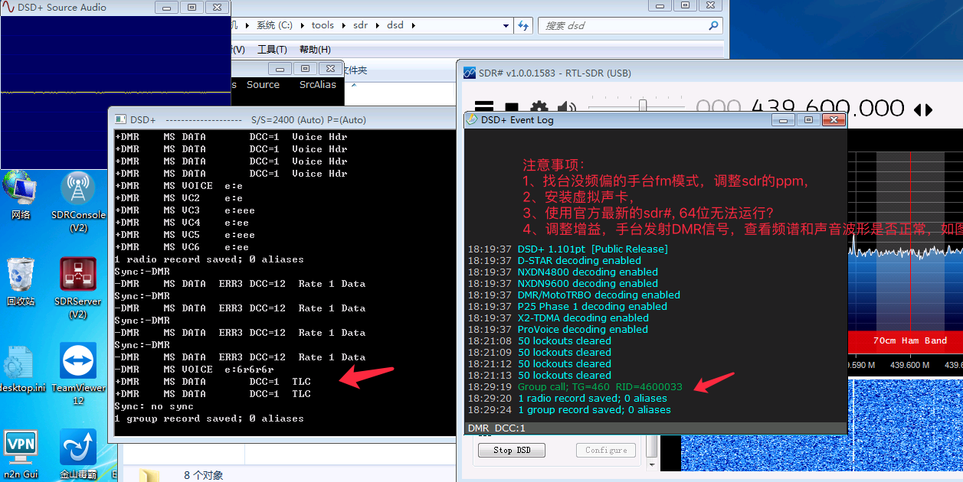

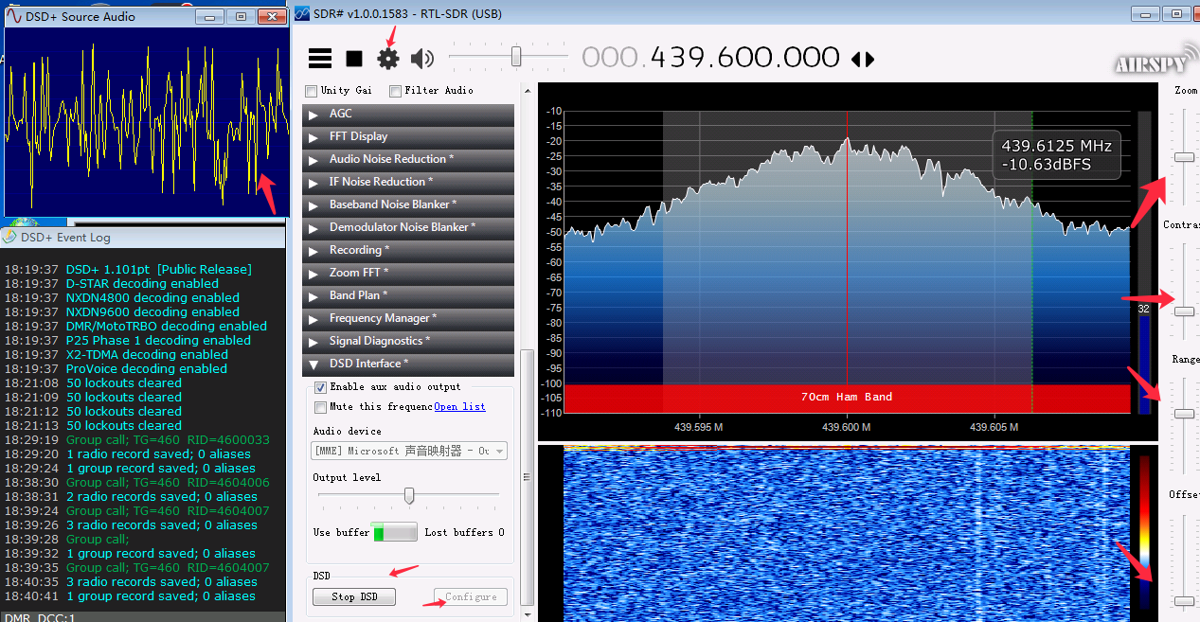
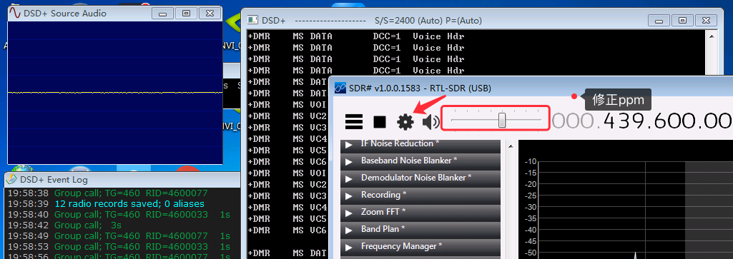

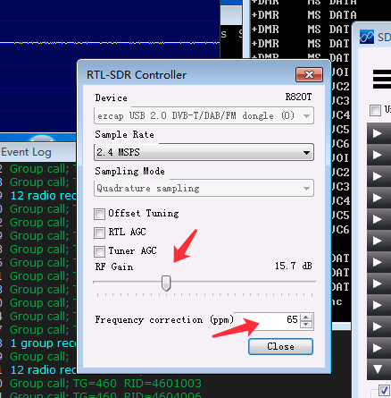

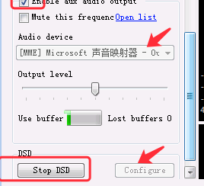

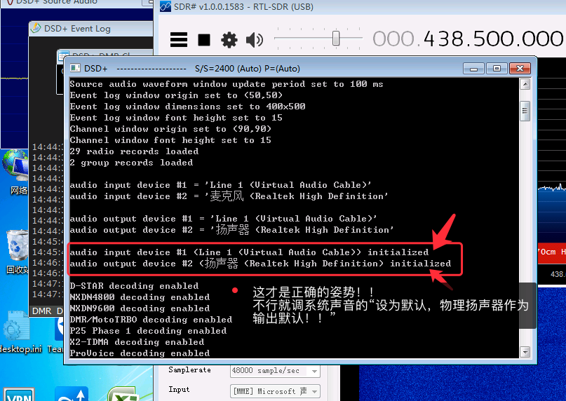

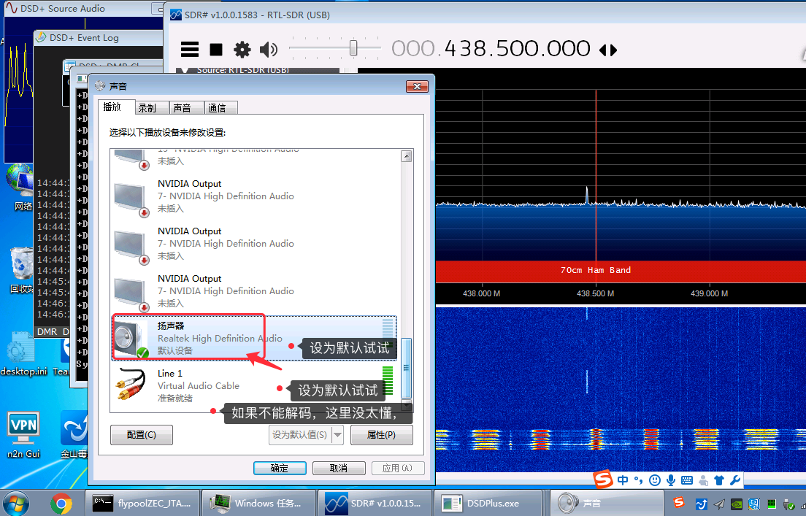

同样可以解码D-STAR，P25数字信号
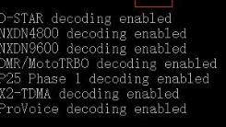

待实践：dsd_decoding_yaesu_c4fm
https://www.reddit.com/r/RTLSDR/comments/3tc9dw/dsd_decoding_yaesu_c4fm/
C4FM解码视频：https://www.youtube.com/watch?v=ELo_ROJ4oy8
